**Fetch Courses**

**Send Feedback**

Let's see how Coding Ninja show up all their courses data on the web page. Of course, they also use APIs for all this.

So let's make use of one of its API that will get all the course details from the server. And your task is to use this fetched data to display on the web page.

You can use bootstrap for the layout of the web page and use only the necessary fields of the fetched data, i.e. the image, the course name and the level of the course.

**The web page initially looks like this -**

[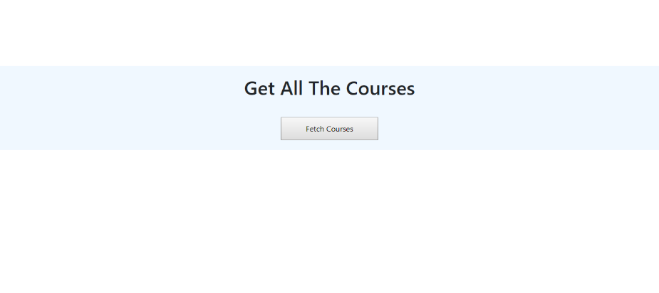](https://ninjasfiles.s3.amazonaws.com/0000000000002051.png)

**After clicking on the button, all the HTML data is removed and the courses are shown on the screen as -**

[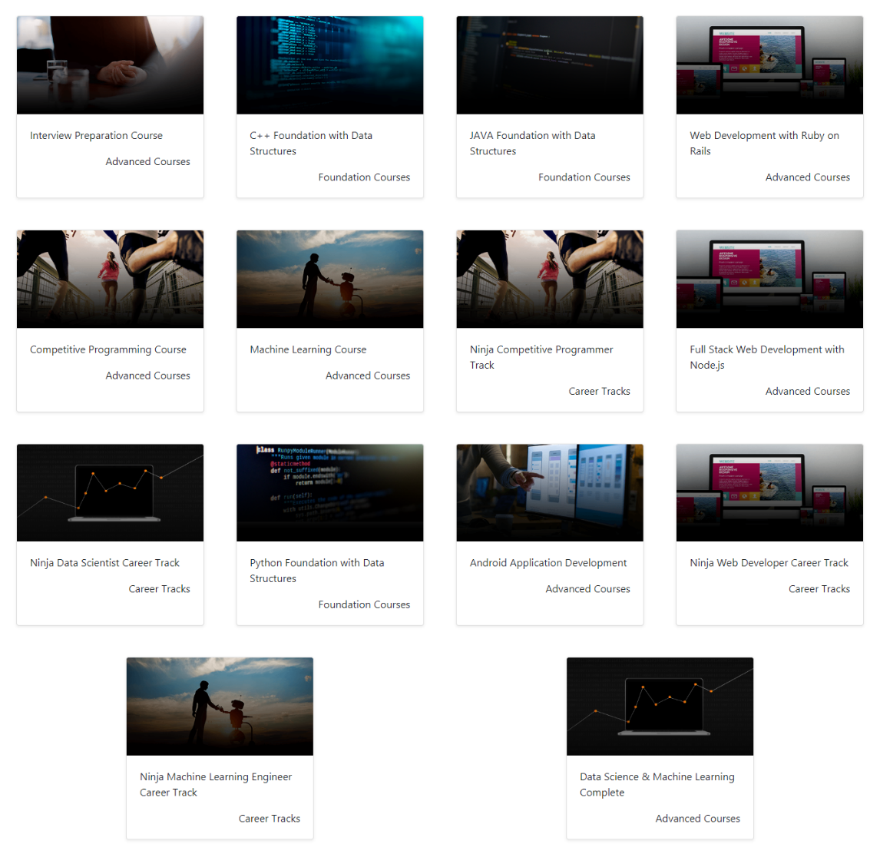](https://ninjasfiles.s3.amazonaws.com/0000000000002036.png)